Git Download Link :

Visit Page : https://git-scm.com/download/win

Then

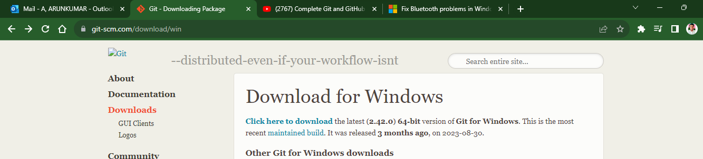

Click on Click here to Download Link

<https://github.com/git-for-windows/git/releases/download/v2.42.0.windows.2/Git-2.42.0.2-64-bit.exe>

Download GitBash Application & Install & Open the App

Repositories /Wesites/ are Github, Git Lab, Git Bucket etc

Git Commands

ls : list all the Things/ Open all the the Details

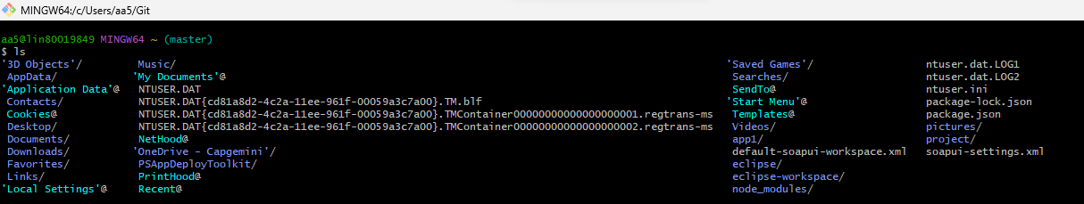

Manually to create a new folder Right click --> new--> Folder but in git

--->mkdir Git : to create a folder called Git

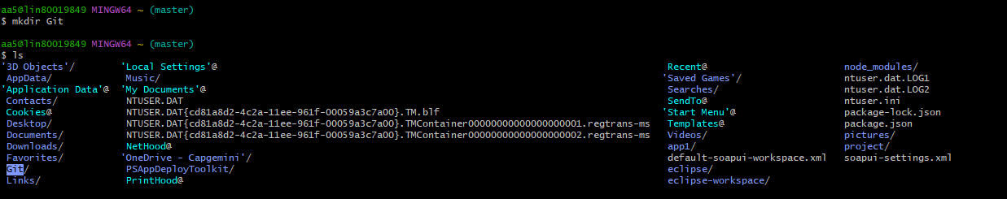

to Double click the Folder(Project) but in git ---> to change Directory : cd Git

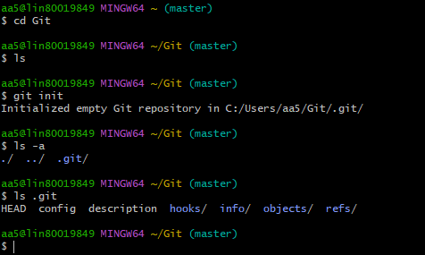

By using **git init** Command, we can check our history Storing Repository/folder

& my Default Location is : Git repository in C:/Users/aa5/Git/.git



To Initialize **git -init**

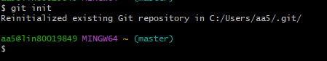

To show all the Hidden File : **ls -a**

These are all my Hidden Files

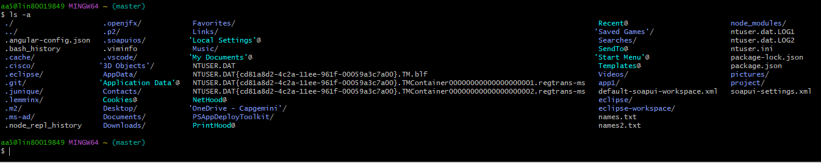

**Working Directory** : is nothing but Untracked files:which are in Red colour shown below

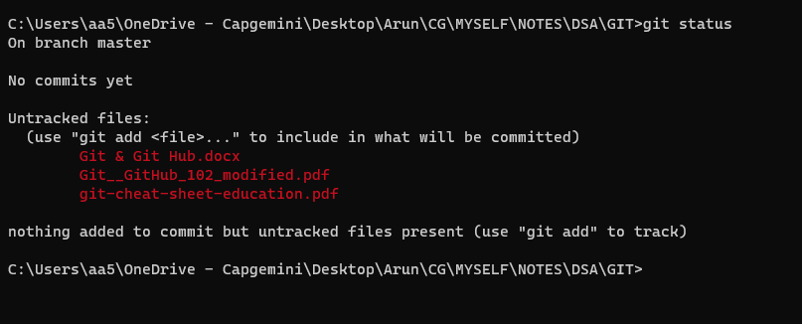

To show all the hidden files in .git folder: **ls .git**

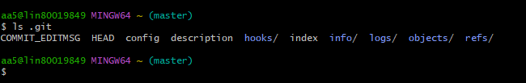

To create a new folder/s we use a command below

**touch names3.txt (**names3 is a name & .txt is format of the file**)**

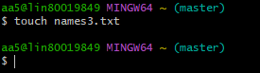

To check Status of Files whether they have been saved or not we use a command

**git status**

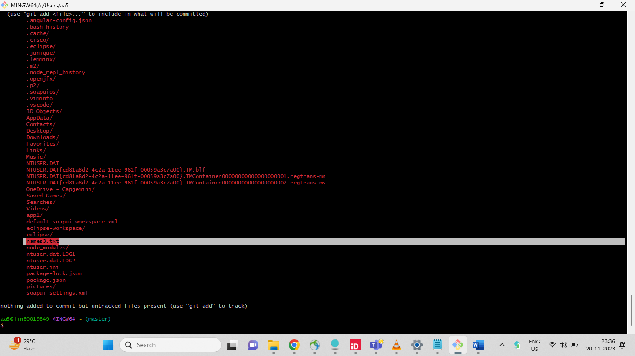

Names3.txt file is not saved yet, so inoder to add this use :

**git add names3.txt**

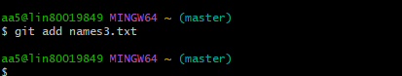

Now I’m checking the status by using the command **git status**

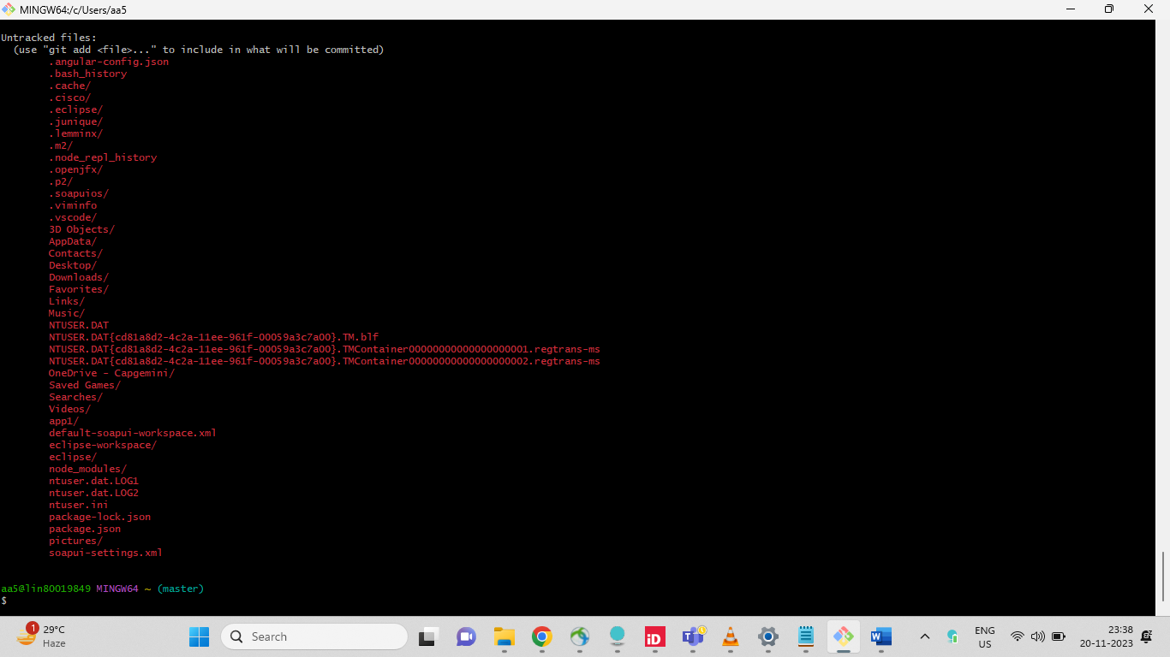

In the above Screenshot there is no names3.txt file name

to commit & add any message : git commit -m "names.txt file is added"

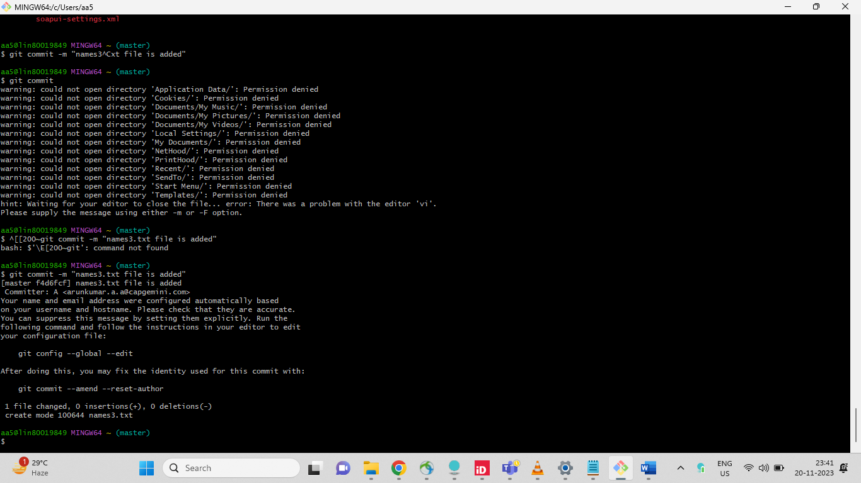

so 5 commands are Imp

**git init** : To Initialize

**git status** : To check Status

**git add** : To add new Files/Folders

**git status** : To check status

**git commit** : To Commit/store

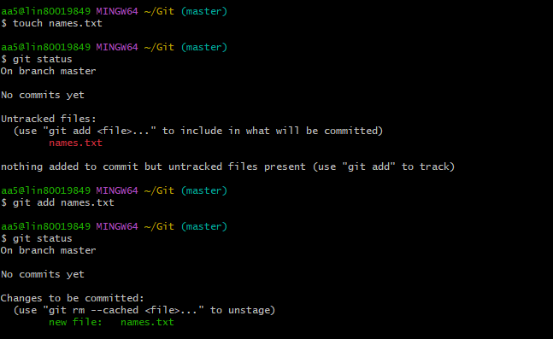

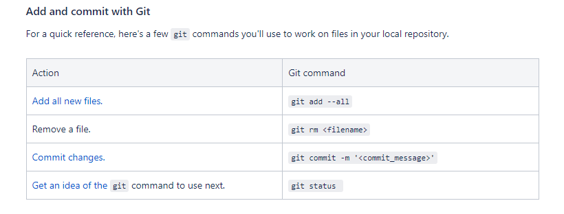

when we try to add something inside names3.txt file using :

**vi names3.txt**

ArunKumar A

BE(eee)

Press Esc button Then :x

To display what are all the changes u made for names3.txt file

Use command **cat names3.txt**

To Remove folders/Files we use : **rm -rf names.txt**

To Remove folders/Files without Committing it we use : **Git restore - -staged names3.txt**

To get back : **git add names3.txt**

To check status : **git status**

To check Entire History of the Project : **Git log**

For Ex: I’’ll create ok.html Page

The changes what I made I don’t want Commit & also Don’t want to loose

Keep these changes in Unstaged area, Then we use a command :  **git stash**

In order to getback those changes we use : **git stash pop (Now they’re in Staging area)**

In order to clear these from Staging Area we use a Command : **git stash clear**

Here I’m created new ok.html Page in my Default work place

